Operations Management in Marine construction, dredging, and land reclamation Project

Quality management, workflow and productivity monitoring, management information systems, Challenges and risk management in coastal structures and ports
Application of theory and Case Studies

Table of Contents
I. Introduction to operation practices and management challenges for a dredging and offshore contractors 2
• Abstract 2
• Historical background: 3
• Shore line extension, Dubai Case 4
• More interests for marine contractors 4
• The operations management challenges for organizations. 5
• Phasing the projects. 5
• The quality management framework 6
II. workflow and productivity monitoring 7
• Early Contractor Involvement (ECI) 8
• Phase gate model in marine construction projects. 9
• Business strategies defined. 10
• Supply chain in marine construction 11
• NEW SUEZ CANAL EXPANSION PROJECT, chain supply challenge 11
III. Management information systems. 15
• Introduction 15
• Importance of management information system in marine construction. 16
• ICT applications supporting offshore construction operations management. 16
• ICT in fleet management and administration operations. 17
• Numerical modeling in marine construction 19
• AI and machine learning applications in marine construction 20
IV. Project demonstration Module, Construction of port in middle east. 21
• Introduction 21
• Key Principles for Ports and Harbor Development 22
• Risk assessment and control measures in marine construction 22
▪ The risks in marine construction relate to: 23
▪ Technological Risks 23
▪ Economic fluctuations risks 23
▪ Exchange rate risk. 24
▪ Counterparty risk 24
▪ The liquidity risks 24
▪ Political and security risks 24
▪ Environmental risks 24
• Khalifa Port Khalifa Construction project cycle. 24
▪ Project Initiation, Defining purpose 24
• Project Planning 26
▪ Khalifa Port Facts 27
• Reclamation, dredging & construction 27
▪ Access to port island 27
▪ Timeline of construction and, Dredging and reclamation. 30
▪ Special system 30
• Khalifa Port Project construction, Challenges, and risks 33
▪ Project time schedule and deadlines, internal and external factors affecting delivery 34
▪ Environmental Risks 34
▪ Budgetary Risks 34
▪ Risk of material and Fuel price costs 35
▪ More specific operational risks related to: 35
V. Bibliography 36

Figure 1Dubai Coastline plans 5
Figure 2The Panama Canal third locks expansion project 7
Figure 3 Suez Canal waterway and the New eastern bypass route 13
Figure 4 Suez Canal extension project Resources, 2014/2015 14
Figure 5 Schematic diagram of the system DGPS 18
Figure 6 Visualization of the project structure using GIS 18
Figure 7 The dredge control and monitoring system (DCMS) 20
Figure 8 Reporting, data logging and trending 20
Figure 9 Suction tube position monitoring (STPM) 20
Figure 10 control and monitoring system for cutter dredgers 20
Figure 11 Remote and autonomous survey vessels 22
Figure 12 Summary of conceptual design benefits and Render of concept AUMD. 22
Figure 13 Khalifa port Construction project cycle. 26
Figure 14 Stack Holder analysis 27
Figure 15 Khalifa port project facts 28
Figure 16 Khalifa port island 29
Figure 17 Gantt chart 32
Figure 18 Khalifa port links 35

Table 1 sourcing and supply chain analysis 14
Table 2 RISK Analysis, Khalifa port Expansion: 33

Introduction to operation practices and management challenges for a dredging and offshore contractors

Abstract
Current article focuses on operation management and related activities in a global marine construction organization. Operations management challenges these organizations currently faces were highlighted. The application of operations principles and their impact on the organization’s success were critically discussed. The quality management framework of the organization is highlighted, as well, describing its role in ensuring that the organization meets its strategic goals
The impact of productivity and workflow on the organization’s competitiveness, was discussed.
With supply chains playing a key role in many operations, I had discussed how a Supply Chain Network design was developed to align with the overall business strategy. Examples including Suez Canal and Panama Canal expansion were discussed.
In clause 3, I Critically discussed the role of management information systems in assisting management towards achieving their strategic goal and operations success within the chosen organization. I conducted a critical evaluation of the role of ICT applications in supporting as well as enhancing operations management, again within the chosen enterprise. requirements, appropriate methods, and technologies such as AI that could help in the optimization of the operations within the organization were demonstrated.
Finally, I had applied a project methodology to address the challenges similar organizations now faces, using construction of khalifa port in Abu Dhabi, UAE, as a model. In doing so, project management scheduling tools, development of the project specifications and other aspects of the project methodology to ensure proper project control, and monitor. Managing the expectations of all stakeholders had been discussed

Historical background:
For centuries, dredging, coastal protection, sea defense, flood control, harbor construction, subsea assets laying, and related mining operations were essential to setup, develop, and protect human societies near shorelines, rivers which tend to flood regularly.
Human societies had been making use of primitive Dredging and land reclamation, in addition to marine construction approaches, to shape the land / water interface to support a variety of human activities.
On banks of main rivers, shorelines, and ocean coasts, marine constructions, canals, ports, break waters, had supported activities like flood risk management, coastal protection, navigation, residential, as well as commercial development.
As ships grow to explore new lands, natural shallow harbors became too tight to accommodate these huge floating structures. Originally big ships had to anchor in open harsh waters due to draft limitations, smaller boats used to transfer cargo and passengers between shoreline / natural harbor and anchored ships. Humans had consistent interest in constructing deeper harbors where bigger ships can be moored. Such ships can carry and deliver more cargo, troops, and passengers in a fast and safe way. To that point Engineers had to face three challenges related to man-made harbors:
- deepening the natural entrance channel and basin of the existing natural harbors. These harbors usually were too shallow to accommodate increasing ship sizes. Here comes the concept of dredging.
- Create artificial protection for natural harbors, thus allowing ships to berth or anchor safely inside basin during harsh weather. There breakwater, groynes, and sea defense activities started to be interesting for engineers and contractors.
- Create artificial vertical deep berths where vessels can be moored away from shallow slops, and dangerous rock banks. Accordingly, passengers and cargo can be direct transferred between berth and ship. Engineers “or contractors that time” improved ancient pile driving methods to create vertical berths. These berths made of timber were not strong nor tall enough to satisfy increasing ship sizes. Engineers learned to cut rocks in blocks, lay on seabed, to create stronger and deeper berths accordingly.
Human societies around rivers had similar challenges. They had to control floods by creating artificial dikes, construct dams on rivers, construct berths to transfer goods and passengers between cities and banks, etc.
Societies in northwest of Europe had to build dikes around to protect from rising sea levels and create new dry lands for their homes and corps.
All these challenges learned Human societies how to dredge, reclaim, construct berths, dikes, groynes, breakwaters, locks, etc.
Nowadays these activities propel projects that amount for trillions around the golpe.
Dredging and reclamation activities are essential for modern economies. Countries in a race to build bigger ports, gain new lands, increase shoreline length, protect old lands, develop modern and prestigious islands for accommodating increasing population and support touristic attractions, dredging waterways to connect waterbodies and develop existing waterways to increase size of cargo being transferred through, and improve safety of navigating vessels.
Expansion of Panama Canal, Suez Canal, dredging of the Dutch Rhine, and Yangtze River in china are few examples.
Land reclamation became an increasingly important and beneficial activity. 70 percent of our planet is covered with water, while dry lands are not all suitable to accommodate increasing populations. Societies with limits flat grounds like Hong Kong and Osaka in japan had no other option except to reclaim new lands in ocean where they constructed huge airports.

Shore line extension, Dubai Case
Dubai in UAE had a very short straight shoreline of few miles. Desert in the background had no interesting chances for development. Land reclamation and dredging projects in Dubai had increased shoreline by 520 km. planned land reclamation projects would even increase shoreline length to more than 1400 Km, compared to original 72 km (Smit, et al., 2008). That adds a huge potential for the city in developing luxuries coastal societies, create touristic attractions and global landmarks to support sustainable economy in a region where oil reserves and production industry drives most of economies.
Figure 1Dubai Coastline plans

More interests for marine contractors
Cables transferring data below oceans, and pipelines transferring oil and gas between countries and continents are other examples where marine construction projects became essential. Dredging of trenching at shore access, and relatively shallow waters is important to protect these assets. Cable and pipe laying activities itself became a greatly interesting activities for marine constructors who had engineered, developed, and modified their classic dredging and construction fleet to be able to preciously dredge trenches, lay down cables and pipelines, backfill trenches above these assets, apply rock and scour protection layers, dredge, and fill material to rough seabed to improve seabed roughness and reduce pipeline free span to safe design limits. Mega trailing suction Hoper dredgers “TSHD” are now able to dig glory holes in seabed to accommodate well heads, and manifolds safely away from floating icebergs in arctic waters.
In modern economies, major oil producers had recently been considering construction of artificial islands to replace aged platforms made of steel. These islands are designed to last for centuries, compared to 20 to 25 years for steel structures. All Exploration, production, and processing activities can be accommodated on these islands. Huge number of wells can be drilled from the same island, crude oil can be processed there, gas can even be purified, treated and liquified there, and finally floating or liquid berths can be constructed to export products direct to global markets. Finally sustainable industrial societies would be built on these islands. In post oil era societies still be able to use these islands in real estate touristic, and attractive applications. These installations are becoming common in the Persian Gulf and Caspian Sea where shallow waters provide and economic justification for such application. Manifa oilfield in KSA, zakum, Hail and Ghasha in UAE, and Kashagan oilfield in northern Caspian Sea, Kazakhstan are examples.
Such engagement of marine construction firms in oil and gas fields development, had added more challenges to the standards of the industry in terms of quality, cost, contractual obligations, etc.

As world prepares for post oil era, harvesting energy from natural resources like wind, tide, waves, ocean current, and solar energy is becoming more interesting for developers and shareholders. Huge spaces above oceans represent a perfect location for these energy fields. Marine constructors are heavily involved in developing and Installation of Offshore wind farms, tidal current and wave energy plants, as well as associating subsea cable laying. Contactors had developed fleet of modern floating vessels for lifting, drive piles, rock filling, trenching, cable laying etc. to meet requirements of these operations.

Current study is not focusing on a certain contractor in offshore construction industry. Generally, study will critically discuss the application of operations principles and their impact on the organization’s success within dredging and offshore construction industry. The quality management framework of the organization will be highlighted, describing its role in ensuring that the organization meets its strategic goals. Current approach will demonstrate such applications applying examples from different organizations, projects, and operations where useful.

The operations management challenges for organizations.
A marine construction Contractor normally faces many operational changes as:
- Dredging and marine construction works usually take place at remote locations adding challenges to chain supply operations regarding accommodation, mobilization, permissions, material and spare parts supply, fuel supply, third party services, etc.
- Marine construction organization usually focus on global market, clients from countries and regions around the globe are of interest for dredging companies. Usually, global contractors have running operations between Siberia, North Sea to east Europe, Africa, middle east, south and east Asia, Latin and north America. That requires quite complicated chain supply and information management systems to connect head office, regional offices, and site offices all together and to external components of the supply and demand chain.
- Marine construction project itself is a combination of many operations including dredging, land reclamation, soil improvement, diving and subsea works, piling, lifting, survey, vessel management, etc.

Phasing the projects.
Normally marine construction project is split into more independent smaller projects. As an example, The Panama Canal Expansion program consists of seven programs or seven little projects basically. The deepening and widening of the Atlantic entrance and Improvements to water supply by raising Gatun Lake maximum operational level by 45 cm to improve the Canal’s water supply and draft. of the GUTUN lake, building third set of locks at the Atlantic and the pacific side, reconstructing both panama locks existing channel and deepening and widening of the pacific entrance (https://micanaldepanama.com, 2015).
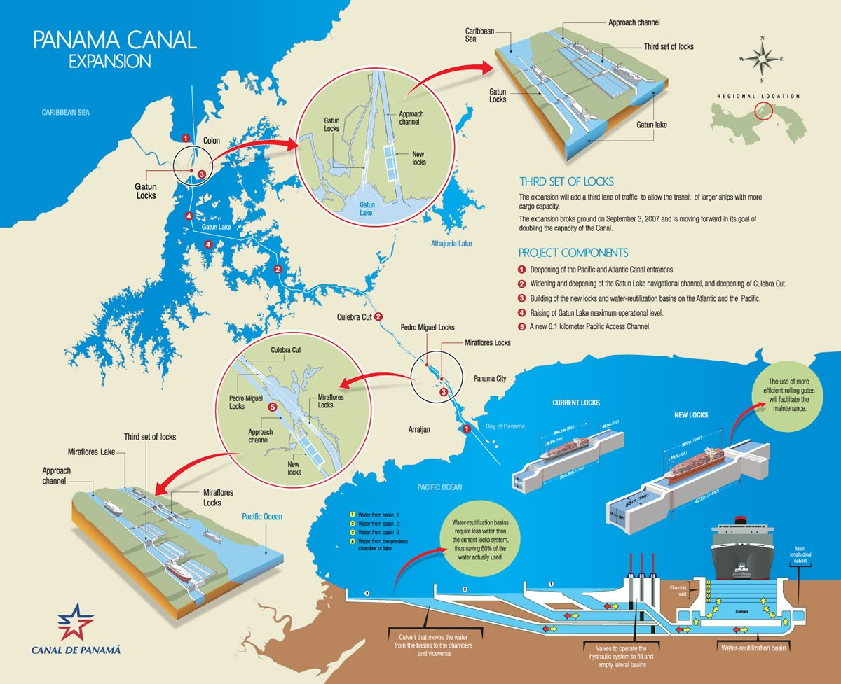
Figure 2The Panama Canal third locks expansion project

The quality management framework
Quality management framework has a great role in ensuring that the dredging or marine construction organization meets its strategic goals. Sharped environmental regulations over recent 5 decades, as well as added complicity to the nature of the contracts in dredging and marine construction projects, all called the need for efficient and strict quality management framework.
Dissolved borders between oil and gas and marine construction, and dredging industries, had added more challenges to an industry used to set priority for power and roughnecks over safety, quality, and environment.
The Quality management Plan first identifies the scope of the Quality Management System. It includes procedures and documents covering work activities as well as a description of sequences and interaction of processes that fall under the scope of the Project Quality Management System.
A Quality Management System mainly contains:
- Quality Plan
- Quality Management Procedures and Quality Management System Matrix.
- Planning, operation and process control documentation such as
- Work Instructions
- Inspection and Test Plan
- Non-Conformity Reports
- Audit Reports and Corrective Action
- Construction Quality Records
- Inspection Checklist
- Test Reports
- Qualification Records
- Construction Logbooks
- Calibration Records
- Traceability Records
- Documented Processes and Procedures
All operation and project documents are identified and controlled as per procedure "Control of Document Procedure",
Records are controlled for identification, storage, retrieval, protection, retention, and disposition. Project record shall be stored in suitable environment to prevent damage or determination and prevent loss.

workflow and productivity monitoring
An offshore construction organization mainly deliver tailored services and products that meets client’s specifications and requirements.
Efficient operation management, workflow and productivity monitoring and improvement is inessential in organization’s competitiveness. Estimating the requirements, collecting accurate environmental geotechnical, and weather data, finding and assessing alternatives, and being well familiar with required permitting and other commercial, social, environmental, and even political regulations is essential to minimize potential deviation from execution plans, reduce incurred costs, increase profits, minimize environmental impact, and maintain safe and healthy working environment.
All that contributes to the classification of the organization relative to competitors in terms of tight metrics applied by clients. Clients for an offshore construction organization will include governmental authorities, oil produces, port states, real estate developers, communication firms, etc.
A dredging, land reclamation, or offshore construction project starts with a problem which need to be solved. Such challenging problems can be:
- Client intends to increase size of import or export, thus requiring deeper and wider canals dredging, bigger ports and berths constructing.
- Current ports’ efficiency is declining due to sedimentation, thus requiring maintenance dredging or change in channel / basin design.
- Client has limited land for social, industrial, or commercial development, thus requiring land reclamation for real estate, airports, etc.
- Client intends to harvest energy from natural resources offshore, thus requiring building of tidal energy plants, installation of windmills, tidal turbines, cable laying, etc.
- Client in short for fresh water and power, thus need to construct seawater desalination plants, and power plants by the shoreline with integrated seawater intakes and outfalls.
- Global warming and rising sea-level threatens existing mainland and islands, thus client need to add or improve sea defense structures and shore protection.
Clients employ international consulting firms, own expertise, or marine contractors themselves to study and advice the very specific nature and specifications of the project to be constructed, or service to be provided. That would include, but not limited to:
- Project feasibility studies, and financial sourcing.
- Meteorological studies including Wind, Precipitation, Air temperature and humidity, Visibility, Atmospheric pressure, and Solar radiation.
- Soil investigation and geotechnical studies.
- Environmental and social impact studies.
- Water levels including, Water level effects, Seiches, Surface water run-off, andLong-term sea level trends.
- Water quality, General, Water temperature, Chemical composition, Turbidity, and Marine life.
- Assessing the present sediment transport regime, and impacts of works on sediment transport.

Early Contractor Involvement (ECI)
ECI provides an efficient means of designing and planning infrastructure projects in a cost-effective, efficient, and cooperative structure, which increases transparency and shared responsibilities, reducing risks and reasons for disputes. (IADC, 2013)
In such involvement, it’s more efficient to consider alternative approaches, Boundary conditions, equipment’ s limitations, and working methods.
Once conceptional solutions for the problem been proposed, based on advisors and consultants’ studies, Designers can prepare initial designs.
These designs will be the base to compare alternative solutions to solve the problem. These comparisons would consider capital expenditures, environmental impact, sustainability, operational expenditures, return on investments, as well as future phasing of the project.
A good design will ensure the desired outcome of a project in the most cost-effective way without undesirable environmental impacts.
Detailed design is essential to develop enough set of specifications to float an international tender for marine contractors.
At that stage, the client should have a reliable cost estimate upon which to base an evaluation of submitted tenders.
At that point, marine constructors would be invited to compete and submit their bids for the delivery of required services, or construction of planned structure or installation.
As tenders been solicited and awarded, construction phase of the project is triggered. This will require:
- Create administration structure and inspection scheme,
- Creating detailed specifications for the contract documents, and
- Set monitoring parameters for construction operations.
Major marine construction will apply their value engineering to propose supply of the project at lowest possible cost, shortest period, and highest quality.
For example, in a port maintenance project, a characterization of the sediments of this site will allow the Port to be established into zones of probable homogeneity of sediments. Moreover, sources of pollution would be identified, with an aim of prevention. Ways of waste improvement need also to be developed. such development requires a mutualization of resources between professionals, research centers and local communities, according to principles of industrial ecology.
While Completion of the construction phases, contractor, and clients should set a plan for the operation and maintenance of the project to ensure that it continues in a proper way. That plan should include well defined metrics and authorities to define, and evaluate defects, liabilities, and remedies during early startup of operation of the project, as well as next period agreed where contractor remain liable for defects related to his extent of scope during design, and construction phases. That can extend over months, or years, from the final handover date.

Phase gate model in marine construction projects.
Marine construction organization will breakdown project activities into smaller operations to find the most efficient way to complete each operation. Such operations would include:
- Project Management
- Engineering, Design Revision, and improvement, Preliminary Planning.
- Modes of construction, i.e., reclamation and dredging methods, Borrow Area Selection.
- Equipment and vessel selection and possible modification requirements.
- Estimations of productivity, compared to applicable rates and time frames, project control, and ways of recording and reporting activities.
- Environmental mitigation measures to reduce environmental impact of the operation and whole project activities.
- Logistical support, manpower resources, and chain supply management.
- Quality assurance and quality control.
- control tools such as monitoring and feedback.
- Financial planning, Identification of Stakeholders, cash flow, etc.
- Subcontracting activities, and charter of equipment.
- Health, safety, and environmental monitoring and management operations.
- Contract management, client relation, and marketing operations.
- Maintenance (after completion of the project).
- etc.
This should be collaborative and involve many parties and disciplines. These parties include:
- planners and control specialists,
- design, cost, and construction engineers,
- dredging and construction experts,
- Production engineers.
- environmental scientists,
- Geotechnical engineers and soil improvement specialists.
- Bathymetric and topographic Survey specialists.
- economists,
- financial planners and accounting team,
- Procurement specialists,
- Contract and legal specialists,
- transportation specialists,
- Site Managers, and site foremen.
- Technical experts,
- Earth moving specialists and workshop team.
- Human resources team,
- Time and storekeepers, and
- Project managers.
To meet demands, an integrated project management or project life cycle approach and efficient operation management plans should be implemented.

Business strategies defined.
Marine construction organizations would define business strategies to include:
- Increase turnover, and profit of the shareholders.
- Increase the volume of order book, and market share of the organization.
- Increase utilization of assets, equipment, and vessels. Increase technical and operational availability of equipment.
- Improve business sustainability and strengthen financial situation of the organization.
Each operation strategies involved in dredging; land reclamation project should contribute to the business strategies of the enterprise. That applies to all key operations including business development, survey, tendering, chain supply, human resources management, information management, dredging, reclamation and material disposal, environmental monitoring, and mitigation, etc.
As detailed above, a dredging or marine construction project will go through several phases, a preliminary design, a more detailed design, a final construction design, and maintenance.
Initial Designs, planning detailed designs must be optimized to utilize selected equipment and assets in the most efficient way.
The complexity of planning a dredging project should not be underestimated.
Estimating the requirements, collecting accurate environmental geotechnical, and weather data, finding and assessing alternatives, and being well familiar with required permitting and other commercial, social, environmental, and even political regulations is essential to minimize potential deviation from execution plans
Accurate Survey and Monitoring of the project site plays an important role during planning, mobilization, construction, and handover stages. An accurate and seamless survey reflects progress rates, production efficiency, potential sources of delay, and enables project management team to continuously improve operation management.

Supply chain in marine construction
Supply chain represents a key operation activity in a dredging and land reclamation project.
A dredging or land reclamation project is so sensitive to supply chain efficiency, especially for planning, sourcing, deliver phases of the chain.
Marine construction, dredging, and land reclamation industry requires management of the flow of goods and services into final products. That includes securing uninterrupted supply of huge quantities of Fuel, lubes, provision, spare parts, rock, sand, gravel, cement, pre-casted concrete objects, third party services for certification and classification, etc.
Mobilization of huge equipment, floating vessels, and thousands of tons of material is a herculean effort. It is a great logistical challenge to Ensure all the equipment and people in place and operations to be carried out within the tight project deadline, to avoid delays in subsequent phases, as well as reduce the chance for disputes.
Sourcing and securing of sustainable supply chain are essential to ensure constant and uninterrupted supply of spare parts, fuels and lubes, construction material, provisions, third party services including laboratories, and material testing, certification of equipment and tools, etc.
All above are must to ensure efficient utilization of assets, adherence to planned schedules, and optimize cost of sales. That contributes to the overall business strategy, and firm’s competitiveness. The major portion of a dredging project’s budget is represented by equipment charter and depreciation rates. A deficient supply chain would bring an expensive marine construction fleet idle. That can take place as a result of deficiency in material supply, testing and laboratory services, third party certification and permissions, vessel repair and classification fuels and lubes, spare parts, logistical, personnel and manning support.

NEW SUEZ CANAL EXPANSION PROJECT, chain supply challenge
in 2014 represents a great indication for logistical challenges in a marine construction and dredging project. On August 2014, the Suez Canal Authority (SCA) unveiled new plans for an additional lane to reduce layup and anchorage delays and allow ships to simultaneously sail in both directions over a greater length of the canal. (Tadini, 2019)
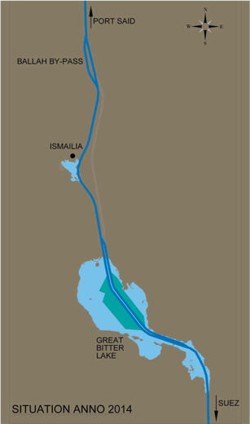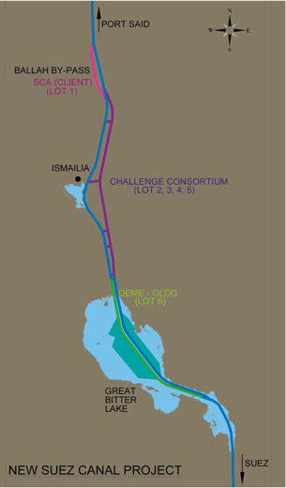
Figure 3 Suez Canal original and the New eastern bypass route
The 35km route had been designed a few kilometers to the east of the existing canal, between enormous sand dunes. In some locations, these sand dunes were as high as 20 meters above sea water level. The total contract value had been evaluated at more than US$2 billion dividend between 6 contractors in two consortia. The dredging works for the project had been completed in a year, which is an extremely tight time frame for the amount of work. In peak, total of 2 million cubic meters were dredged in a single day, along the route of the project. Scope had been awarded so that:
- Excavation and disposal of 260 million m3 of wet sand between:
  - SCA dredging fleet to dredge 15 million m3 in lot 1.
  - Challenge Consortium to dredge more than 200 million m3 in lots 2 to 5.
  - Dredging International & Great Lakes 45 million m3.
- Furthermore, before the dredging operations, dry excavation works in the desert had to be carried out by the Armed Forces Engineering Corps of the Egyptian Army to clear 250 million m3 of dry earth (IADC, 2015).
- The US$8.4 billion goal Funding for the project. Came from the Egyptian public who had invited to purchase of interest-bearing investment certificates.
the project was divided into six separate lots where dredging had been carried out between 51.4 - 122.4 km of the canal length.
Challenge consortium had managed to mobilize twenty one cutter suction dredgers, five trailer suction hopper dredgers, and two water injection dredgers, as well as, more than fourty pieces of auxiliary equipment and 80 kilometers of floating and shore steel pipelines.
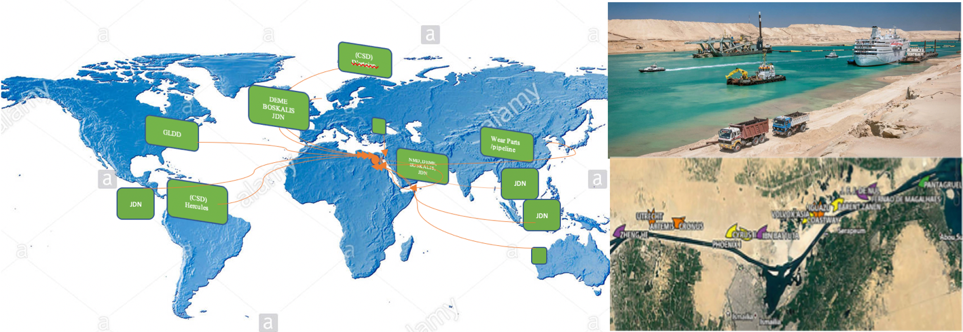
Figure 4 Suez Canal extension project Resources, 2014/2015

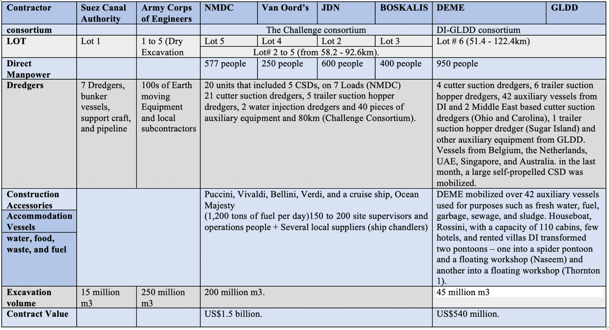
Table 1 sourcing and supply chain analysis
The first dredger from NMDC was on site 14 days after signing the contract. CSD Hercules was re-routed to Suez on a semi-submersible transport vessel. It was on her way back from Brazil to Rotterdam. Figure 4 indicate the extent of sourcing and mobilization process.
All six contractors from the two consortia had to manage complicated mobilization operations for their own, as well as chartered, vessels, equipment, and staff from all over the world. That was organized from each of their head offices. Mobilization was an ongoing process during the project.
- The vessels for Royal Boskalis sailed or brought from around the globe. First vessel arrived at site by early December. Royal Boskalis had also managed to mobilize about 400 people for the project.
- Jan De Nul had managed to mobilize 7 cutter suction dredgers to the new Suez Canal project. 2 vessels sailed from Dubai, 2 arrived from Vietnam, 1 from Singapore, 1 from Panama and 1 from Belgium. 20 kilometers of shore pipeline and 3km of self-floating pipeline were mobilized. About 600 people were mobilized to the project, as well.
- NMDC mobilized a total of 20 vessels of theme, 5 cutter suction dredgers, as well as, around of 577 people
- The Consortium had also to manage subcontracting labor force from Egyptian local market including operators for bulldozers and pipefitters.
With a huge ongoing project and works being carried out 24/7, it was essential for the Consortium to ensure that hundreds of employees had good accommodation. However, given the work location and insufficient facilities for employees on land, the Consortium came up with the solution of living quarters on water ( VAN BEMMELEN, et al., 2016).
During the peak period of the project, 1,100 people had to be accommodated every day
Four accommodation barges were hired, Puccini, Vivaldi, Bellini, Verdi, and a cruise ship, Ocean Majesty. Also, four hotels were used to accommodate crew and staff.
Due to massive number of people and equipment present, Supply of water, food, and waste disposal were also issues that needed to be perfectly planned, and timely managed. many local suppliers were contracted for catering and cleaning services.
Fuel was efficiently delivered by the client. During peak operation of the project, fuel consumption was about 1,200 tons of fuel per day.
On lot 6, at the great bitter lakes, Dredging International submitted its tender on 20 September. meanwhile, DI started looking into possible mobilization.
It took about four weeks to look into the tender documents and negotiate
DEME’s biggest cutter Dredger, D'Artagnan, was at another project in Siberia, re-routed to Belgium for a quick stop for a few days to take spare equipment for Suez and then set sail to the project site. Other equipment and pipelines from the United Arab Emirates also arrived later in November. More equipment and vessels arrived till the beginning of February.
About 950 people were mobilized to the project. A houseboat was rented, with a capacity of 110 cabins, few hotels and villas were rented for the staff, that’s in addition to accommodation on vessels.
Safety had not been scarified by the huge amount of equipment and workman force onsite, neither by tight time frames considering the strategic nature of the Suez Canal area.
Finally, proper management of complicated chain supply, which extended across all the planet, as well as operational achievements to coordinate such huge amount of equipment, material, and people was behind the successful completion of Project within a year.
On the other hand, from the point of view of risk related to demand, the intensity of work and commitment of the client to deliver the project on time had reduced the risk of fluctuations in demand and allowed the supply chain to work at highest possible efficiency at all times of the project.
Average wait times for vessels transiting the canal were as high as 8 to 11 hours and were often unpredictable. Unpredictable wait times were especially troublesome for container ships, which accounted for more than 50% of Suez Canal traffic (BACCELLI, et al., 2019)
Due to improved navigation safety, and increased availability of the water way, the Egyptians expects the revenues of the canal to increase from US$5.3 billion in 2014 to US$13.2 billion by 2023.

Management information systems.

Introduction
Management information systems has a great role in assisting management towards achieving their strategic goals and operations success.
Dredging, land reclamation and marine construction operations are of global nature. A huge amount of information is essential for management to steer the organization towards it’s strategic goals. The most markable of theme is to expand over global market, deliver project at competitive rates, and highest quality, attract and acquire expertise in the industry, ensure safe working environment, and avoid or minimize impact to the environment and ecological systems at the offshore construction sites. R&D, and development of new technologies to optimize construction operations and help clients to harvest energy from renewable energy sources at competitive cost is a strategic goal of no less importance than above goals, for a marine construction firm.
Management information system is quite complicated here considering the size of information and data need to be collected, stored, processed, and exchanged. Both internally within the organization, and externally with potential clients, business partners, suppliers, research centers, governmental and regulating authorities, third parties involved in regulations and certifications, etc.

Importance of management information system in marine construction.
An efficient management information system will equip management with enough tools to:
- Collect data from clients, research centers, governmental and regulating bodies for the potential projects while in early study phases. ECI improves efficiency of project designing and planning. That improves transparency and shared responsibilities, reducs risks and chances for disputes.
- Create an efficient and useful data base regarding soil and geotechnical structures, met oceanic conditions, coastal and offshore ecological systems in the areas of potential operations. Such information would be of a great importance for Engineering, planning, tendering, and operation management teams as well as managers. Despite clients usually provide enough information at tendering stages of each unique project, it remains contractor responsibility to make itself familiar with site conditions, as well as regulatory and environmental constrains applicable.
- An efficient information management system would ensure proper ways of performance reporting, document control, and logs for data feedback from operation sites. That’s extremely useful in tuning operations and execution plans to meet strategic goals of the operation and the organization. Meanwhile processing of feedback data from operations greatly improves operation management philosophy in the organization and sharpen operation and planning teams’ ability to improve future operations. Thus, reducing uncertainties usually related to dredging, land reclamation and offshore construction operations and projects.
- developing and implementing a management plan, defining project goals, and periodically reviewing progress.
- Develop long term strategies for the organization. e.g., improve management ability to take decisions regarding adding capital expenditures, which may include designing, construction or conversion and upgrade of existing assets. Management would be able to take decisions to add new or reinforce regional offices, acquire, or reinforce subsidiaries and affiliates, merge or join external ventures.

ICT applications supporting offshore construction operations management.
Dredging is a complex process consisting of multiple steps and is characterized by a large number of parameters. For prompt and effective management of dredging at all stages of production it is necessary to take into account a variety of parameters and be able to compare different data.
In pre-preparation and design stages, and production work, the use of dredging projects in geographic information systems (GIS), Global Navigation Satellite Systems (GNSS), and monitoring systems and automated control of hydraulic digging process, to simplify the task of monitoring and control site to be developed (Nyrkov, et al., 2015).
Figure 5 Schematic diagram of the system DGPS | Figure 6 Visualization of the project structure using GIS

In addition to GPS, GIS, and GLONASS Systems, a wide range of ICT systems and applications are essential for efficient and accurate dredging, land reclamation, and marine construction operations. ICT applications related to stock control, are of a great importance to ensure efficient stock control, optimal reordering and ordering quantities, material flow from suppliers to regional yards, and work sites. All contribute to minimize lost time due to chain supply interruption.
Meanwhile, accurate record and processing of procurement activities, spare parts, wear parts, fuel, and other material contributing to the cost of operations lead to sharper evaluation of the ongoing operations’ efficiency, and more accurate estimation of similar operations in the future.
e.g., in dredging and land reclamation operations, the contractor aims mainly to minimize the cost of cubic meter of soil to be excavated, transferred, or reclaimed. Efficient management of material procurement and linking these costs of sales to worksite conditions is of great assist to operation management and planning teams. These links would include geotechnical and soil condition, Meteorological and weather conditions, etc.

ICT in fleet management and administration operations.
Marine constructors usually manage a huge fleet of owned, and chartered vessels, and equipment. Each piece of equipment has strict certifying system with sharp renewal dates. That takes place in close coordination with global ship repair facilities, and international classification societies. What makes that hard to control without efficient ICT tool, is the global nature of operations, which requires understanding and management of these activities with partners around the globe.
Pro-active vessel and equipment management systems are of a great importance to operations. Monitoring operations and condition of a fleet in operation in 5 continents requires complicated and detailed preventive, and predictive maintenance programs and applications to be employed. All dredging contractors use sophisticated, complicated, and to a great extent, tailored applications to ensure Real time Exchange of maintenance records and condition report between vessels, sites, regional and head offices.
Similar applications serve to report and monitor progress monitoring, records and logging of operations and activities in the project. That provides management with clear image of progress in operations, potential complications and delays, invoicing and cashflow, etc. So, management of organization and planning teams can build a solid model for the current and next application of operation teams and equipment.
Dredging and marine construction operations also use tailored ICT solutions to help in improving efficiency and accuracy of operations including design, tendering, logistical, and administrative, HR and talent acquisition, procurement and chain supply operations. These systems mainly developed to improve process control, reporting, data logging, trending, and data display, and graphical presentation of the operations and records. these systems included:
- Dredge Control & Monitoring Systems:
  - Control and monitoring of the dredging process.
  - Automatic functions and procedures.
  - Production monitoring.
  - Reporting, logging and trending.
  - Dredge chart operations (survey system).
  - Diagnosis for the ship’s machinery systems.
- Special functionalities for suction hopper dredgers
  - Suction pipe position monitoring (STPM).
  - Draught and loading monitoring (DLM).
- Special functionalities for cutter dredgers
  - Automatic cutter control.
Figure 7 The dredge control and monitoring system (DCMS) | Figure 8 Reporting, data logging and trending
Figure 9 Suction tube position monitoring (STPM) | Figure 10 control and monitoring system for cutter dredgers

Numerical modeling in marine construction
For centuries, human societies have been using Dredging and land reclamation, in addition to marine construction, to shape the land / water interface to support a variety of human activities.
On banks of rivers, shorelines, and ocean coasts, marine constructions, canals, ports, break waters, had supported activities like flood risk management, coastal protection, navigation, residential, as well as commercial development, And hydro-power development.
That has always been guided by an understanding of the costs and benefits. However, in the last few decades the understanding of what constitutes costs and benefits has evolved substantially beyond the direct monetary costs. This was aided by the environmental movement over the last decades, where the costs were expanded to include the negative environmental impacts that can be associated with dredging.
Today, numerical models can be built to predict environmental impact of a marine construction on the local ecological systems. Such models make use of the massive data bases available, strong processing capacities of modern computers, and interactive graphical presentation of such data.
For example, tidal power plant cand be modeled to show effect of such structure on marine life, and coastal environment. Models are normally built to demonstrate more than a scenario, and design. Expertise, regulating authorities, and management will consider option that provides minimum environmental impact compared to other scenarios. Such studies and mofeling processes might need years to provide best mitigation measures to reduce environmental impact and carbon print of the operations and the project. In many cases, prototypes and physical models will be built to verify numerical model predictions.
Palm island and tidal plants in south Korea and France are examples of such application of numerical models in marine construction operations.
Other numerical models built using Computational fluid dynamics (CFD) can predict performance of marine structure in different weather scenarios. Ports, harbors, breakwaters, dams, tidal plants and wind farms are now built to serve efficiently over the designed lifetime. That means improved sustainability and economy of these structures. Numerical models and CFD makes sure that figures assigned in design are not over or underestimated.

AI and machine learning applications in marine construction
ICT applications in marine construction operations had greatly improved over the first two decades of the second millennia. Today, AI and machine learning applications had already secured a markable role in the complicated operations of marine construction.
A great example of such AI applications is the unmanned survey vessels. These vehicles independently navigate oceans and territory waters for weeks. Collecting path metric and seismic data, transferring direct to shore-based team of scientists and engineers to creating accurate and detailed path metric maps of the seabed, as well as geotechnical formations.
Such application of AI in survey operations had a great advantage in:
- Improving personnel safety. All human teams and most of expensive processing equipment are shore based. Thus, risks related to offshore operations are minimized.
- Improving efficiency of resources management. A single shore-based maintenance is able to monitor and process survey data from multiple unmanned survey vessels simultaneously.
- Reducing time and improving accuracy of survey models. Simultaneous collection and processing of data greatly reduces the time required to generate accurate surveys. Meanwhile application of strong computers and servers.
Earlier, big teams of surveyors, captains, and seamen equipped with big fuels with enough accommodation, and provision used to sail for weeks and months to collect these data.

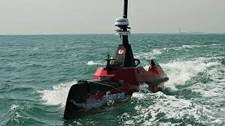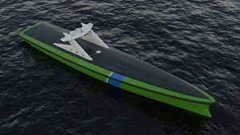
Figure 11 Remote and autonomous survey vessels
Modern Marine construction vessels like dredgers, piling cranes, ROVs, Pipelaying vessels, cable laying vessels, and Dynamic positioned vessels itself are a kind of intelligent machines. Integrated systems, and complicated networks of PLCs and the remote I/O components, connected via a fieldbus network to strong processors and processing units.
Such vessels are able to dynamically position itself in strong winds and severe sea conditions, monitor and control operations, automatically deploy and recover equipment from seabed, and autonomously controls cranes, dredging equipment, pumps, cutter units, winches, cranes, etc.
A single man controls all dredging equipment on a big trailing suction hopper dredger TSHD, which includes more than 4 dredge pumps, two jet pumps, two drag arms, and much more systems. In most cases, operator function is to monitor the systems autonomously working.
VR simulators provide crew with real life scenarios in shore-based training facilities. Today, Simulators simulate operation of dredgers, support vessels, pipelaying and other marine construction vessels. That greatly improves safety margins, and enhance technical skills of crew on these vessels.
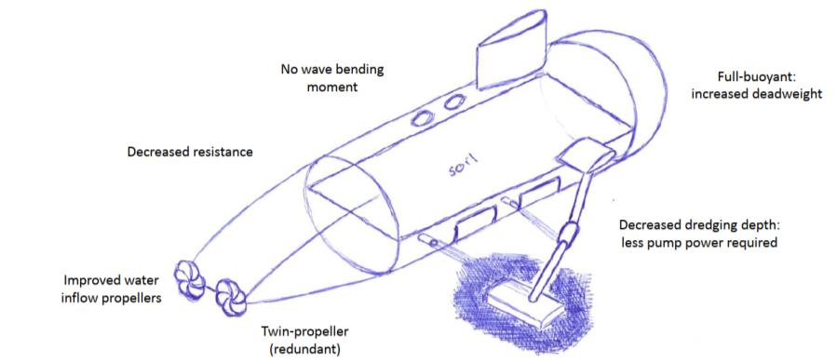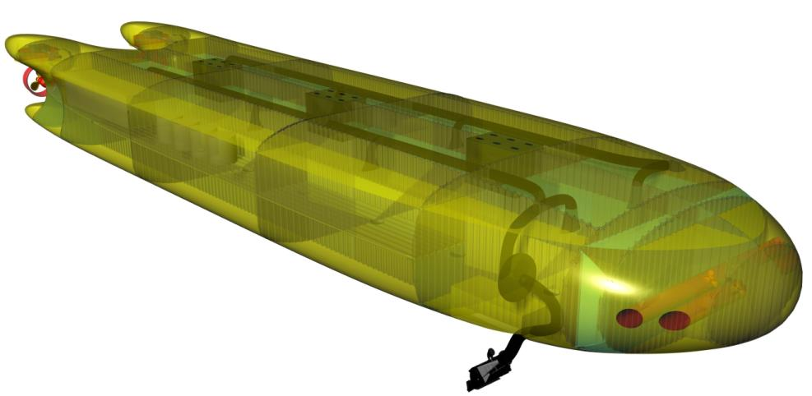
Figure 12 Summary of conceptual design benefits and Render of concept AUMD.

Project demonstration Module, Construction of port in middle east.

Introduction
The global need for coastal facilities has risen dramatically in the last decade due to growing commercial, industrial, and recreational needs. New ports and harbors are being developed and existing facilities expanded with great momentum.
Port facilities not only require large areas of coastal land and waters for their construction, conversion, or extension, but also for the operation of all port installations, accompanying industrial and commercial installations and transport systems. The impacts of ports on the coastal environment are considerable, but often development of the ports and harbor facilities is unavoidable given the national and global economic significance of their intended use. Maritime transport carries the bulk of the world cargoes and is considered the most environ- mentally efficient mode of transportation.
Efforts to significantly minimize the impacts of ports on the coastal environment must be thoroughly considered in planning and design phases. To address sustainable port development, The adoption of good management practices during planning, design and operations, in which an optimal balance between socio-economic activities and physical, morphological and ecological issues.

Key Principles for Ports and Harbor Development
The effect of ports on the coastal environment may be not only in terms of the environment but also on economic and social well-being of communities dependent on coastal resources. The emerging consensus is therefore, for the adoption of good management practices during planning, design, Construction, and operational phases to achieve the optimal balance between socio-economic activities and their impacts on the physical, morphological and ecological features of the area (Dr. Anjan Datta, 2014).
It's thus essential to minimize the impacts of port development on the coastal zone within an economically and socially sound structure.
- Port development must be compatible with national port development plans and coastal zone management plans.
- Port development agencies/ authorities should discharge their mandate for port and harbor development in an environmentally responsible manner.
- Conduction of an environmental impact assessment (EIA) is an essential step early in the planning phase
- Enhancing environmental performance should be part of the mission of the port itself, which should apply required monitoring and operational policies.
- Proper site selection and design phases during planning for port and harbor development to minimize negative social and environmental impacts
- Adapting technologies that are environmentally friendly during all dredging operations and management of dredged material.
- Coastal engineering structures should be designed to not cause aggravated coastal erosion in adjacent areas significantly or disrupt the sediment budget within the region.
- Regional and international co-operation and strategic partnerships promote improved environmental performance.
- Sustainable port and harbor development requires a culture of dialogue, consensus building, partnerships and co-operation

Risk assessment and control measures in marine construction
A global marine contractor usually faces a wide range of project execution risks. Including pricing, design, and operational risks in addition to weather, environmental, and geotechnical risks. Management have also to consider technological risks, as well as financial risks, including, Economic fluctuations, exchange rate risk, counterparty risk, and the liquidity risk. All related to global nature of business. (DEME SUSTAINABILITY REPORT 2019, 2020)
Due to global nature of operation, Political and security risks sometimes became a challenge for management as well.
Dredging and marine contracting activities are unique in nature and design, with predefined terms and within an agreed time frame, for a lump sum or unit price for a well-defined scope and quantities.
Normally projects including marine construction, dredging, and land reclamation projects subject to extensive analysis to verify the feasibility of spending hundreds of millions on such activities, evaluate the risks might interfere with construction phases, and estimate the different impact of the project on local environment and societies.

The risks in marine construction relate to:
- The price of the project or job. In case of divergence between the anticipated price and the actual price because of variations in the unit cost and/ or quantities stated in the tender.
- Increase of oil and fuel prices during the contract.
- The possibility to obtain coverage for additional costs and price increases.
- The design, if that’s part of the contractor’s scope.
- The obligations and liabilities and terms of the contract. As applicable by the local governing laws at the country or region of contract signing or arbitration.
- Control of the elements included in the cost price,
- Project schedule and deadlines, internal and external factors which may affect delivery and benchmarks of the project.
- Performance obligations, quality and deadlines, and the related direct and indirect consequences.
- Warranty and defect liabilities.
- Compliance with safety and other related obligations.

Technological Risks
- Technical parameters including type of vessel, capacity, power, and expertise in new technologies.
- The period between the investment decision and vessel commissioning and anticipating future market developments.
- Control over construction by the shipyard once the investment decision made (cost, performance, conformity, etc.)
- utilization of the fleet and scheduling of activities.
- Financing.
Maritime activities is capital- intensive. There is a regular need for investment in new vessels to maintain the fleet at the leading edge of technology. Maintaining fleet and technology updated with latest trends in industry avoids the risk of obsolete technology and equipment which results in reduced efficiency, extended delays and breakdowns, and increasing cost of sales.
As explained here, a marine construction firm is usually involved in complex investment decisions and related operational risks.

Economic fluctuations risks
Economic fluctuations on both the domestic and international markets are of significant impact on Marine construction and dredging sector. The economic climate influences the investment policy of private sector customers, and of local and national authorities.
Considering challenges related to diversity of activities and geographical locations, marine construction firms are exposed to a complex regulatory environment based on the places where services are provided.
Firms are subject to rules concerning administrative contracts, public and private works contracts, and civil liability. Amongst others, tax legislation can be very complex, is subject to change and is often interpreted in different ways.

Exchange rate risk.
Contractor usually hedges against fluctuations in exchange rate. Price risks of materials, such as fuel, can also be hedged for contracts that do not contain price revision mechanisms.

Counterparty risk
The large number of customers being serviced globally by an international marine contractor usually control counterparty risks. To contain the risk, constantly monitoring the outstanding trade receivables and adjusts its position where necessary, is essential.

The liquidity risks
An international marine contractor mitigate liquidity risks by spreading the credit and guarantee lines over several financing organizations and banks.
Moreover, a marine construction firm mainly invests in capitals and equipment with a long lifespan, which is written off over several years or decades.

Political and security risks
Firms are also exposed to political risks as political instabilities, regional and civil wars, armed conflicts, terrorism, hostage-taking, extorsion, and sabotage. That might threat the security of staff and property. These risks are monitored and, if necessary, a project can be stopped, and staff and equipment are transferred to a safer location.
Firms usually appoint an enterprise security officer to provide regular updates on potential threats to the security of staff and properties, help setup security procedures, verify compliance with these procedures, and coordinate emergency situations when necessary.

Environmental risks
Environmental risks fall into two categories:
- Disruption to fauna and / or flora or accidental pollution, which can never be totally ruled out despite the very strict prevention measures that the company takes in performing its work.
- Decontaminate highly polluted soils, the extent and exact composition of which is not always easy to be recognized in early bidding and contract stages. Technologies used to remediate soils can also contain a degree of risk.

Khalifa Port Khalifa Construction project cycle.

Project Initiation, Defining purpose
Abu Dhabi Economic vision 2030 targets stable and sustainable growth of GDP to $416 billion level by 2030. By then non-oil Gross Domestic Product of Abu Dhabi is intended to contribute to 64% of the emirate GDP. By 2030, Kizad and Khalifa Port are anticipated to raise more than 14 per cent of the non-oil Gross Domestic Product of Abu Dhabi.

Figure 13 Khalifa port Construction project cycle.

power | H | AD funds |  | AD Ports
 |  | Environmental agencies |  | PORT EPC Consortium
 |  | Government and local authorities
 |  | investors
 |  | Keep Satisfied |  | Manage Closely
 |  | Social and public authorities |  | Customers
 |  | Competitor ports, Local and global |  | Strategic Partners
 |  | Press / media |  | Advisors
 |  | Local Society |  | Subcontractors
 |  |  |  | Employee
 |  | Monitor, Minimum Effort |  | Keep Informed
 | L | L |  | H
 |  | Interest
Figure 14 Stack Holder analysis

Project Planning
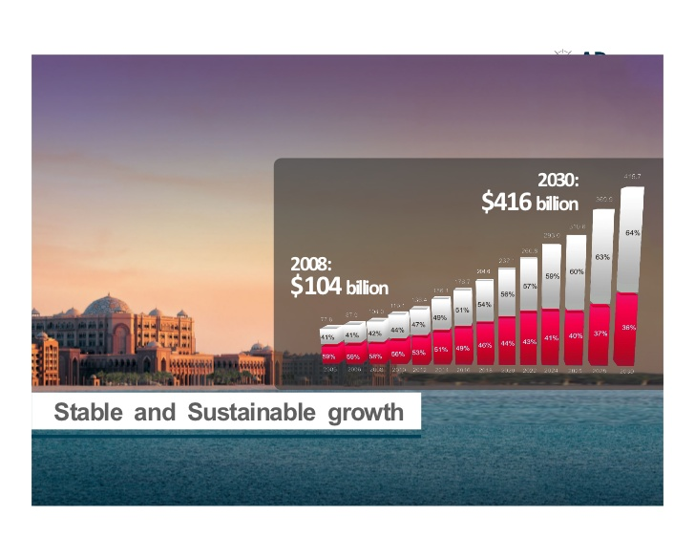
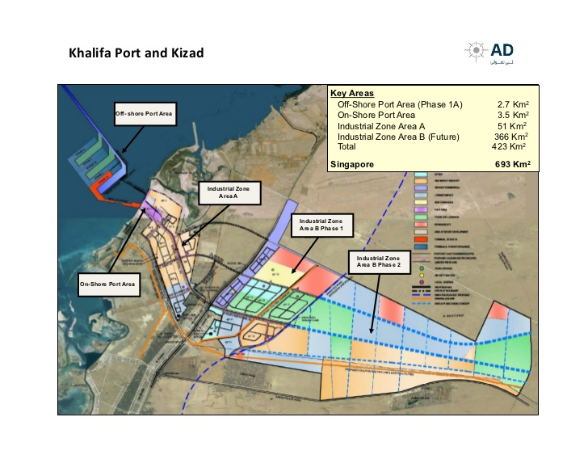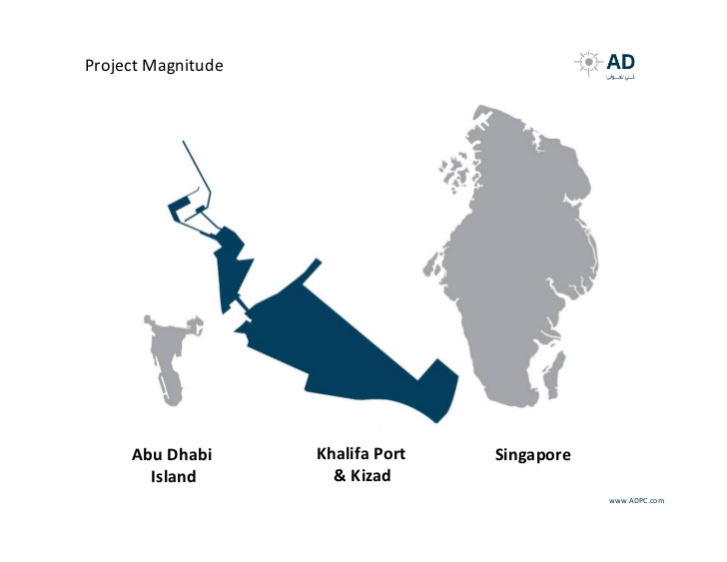
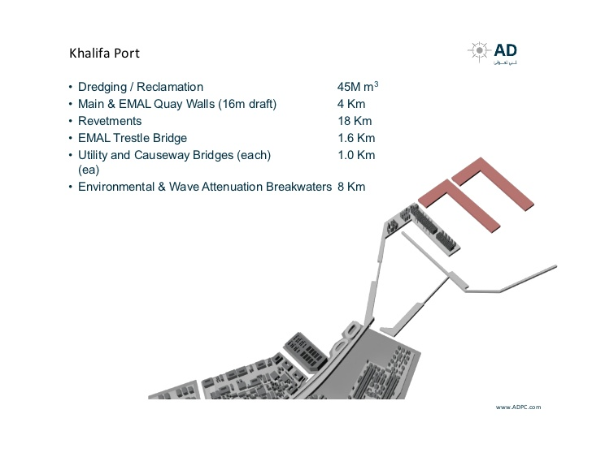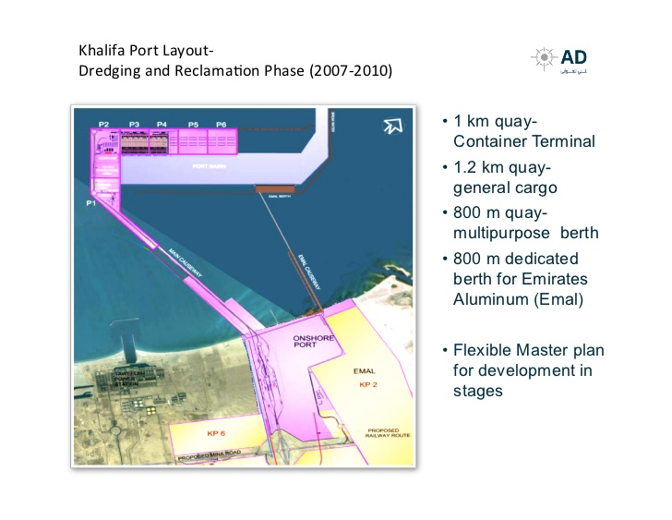
Figure 15 Khalifa port project facts

Khalifa Port Facts
- Multi‐purpose maritime facility located 5 km offshore
- Replaces the existing port in the center of Abu Dhabi City
- Offshore port area approx. 3.0 square km
- 50 square km industrial zone
- Gateway
  - Import cargo into Abu Dhabi
  - Export Industrial zone goods
  - KIZAD destination port
- Phase 1A throughput
  - 2.5 million container TEUs
  - 12 million tons of general cargo
  - Separate terminal serving EMAL, the largest aluminum smelter in the Middle east.

Reclamation, dredging & construction
- Port island platform made from reclaimed seabed material
- Rock revetments and breakwaters protect outer perimeter of
- port island
- Dredging
  - 45 million cubic meters
  - Port basin 16m deep.
  - Approach channel 250 m wide, 16.5mdeep, and 12km long

Access to port island
- 3.2 km causeway including a 1km long highway bridge
- 3.5kmcauseway/trestleconsistingof1.7kmcauseway and 1.6 km trestle bridge
- 800 m long terminal for Emirates Aluminum

Khalifa port contains an initial stage capacity of 2.5 million Twenty-foot Equivalent Unit containers and more than 10 million tons of general cargo every year and an anticipated aptitude of over 14 million Twenty-foot Equivalent Unit containers and over 30 million tons of general cargo every year by 2030.
By 2030, section A and B of Kizad will constitute part of the biggest industrial regions across the globe at approximately 420 square kilometers. A size comparable to a state area of Singapore
By 2030, Kizad and Khalifa Port are anticipated to raise more than 14 per cent of the non-oil Gross Domestic Product of Abu Dhabi.
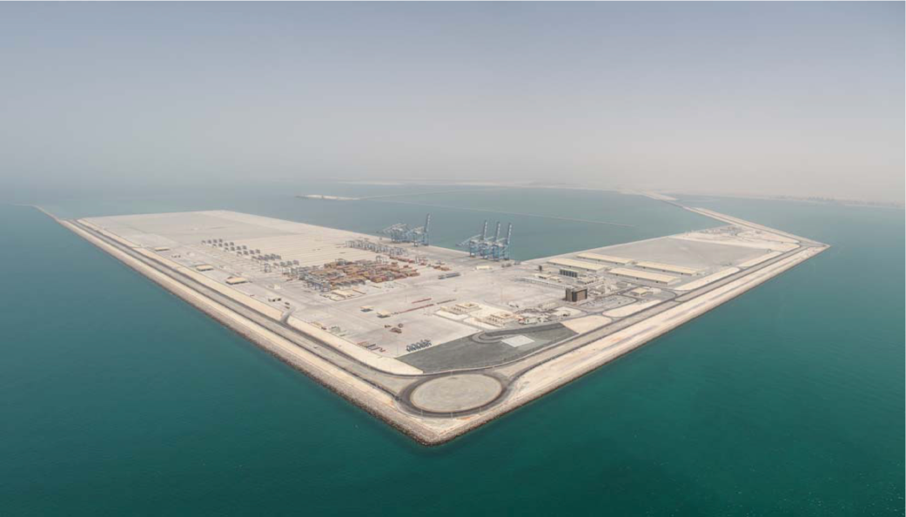
Figure 16 Khalifa port island

Timeline of construction and, Dredging and reclamation.
In June 2007 the Khalifa Port Marine Consortium (KPMC) was formed with partners Boskalis Westminster Middle East Ltd., Archirodon Construction and Hyundai Engineering & Construction. In October 2007 KPMC was awarded a multi-faceted design, procurement and construction contract. The specified work included dredging of an access channel and port basin, land reclamation, rock protection works, breakwaters and quay wall construction
When the contract was awarded, most of the final design work for the port’s construction had yet to be done. The client – Abu Dhabi Ports Company (ADPC)
Although the contractual completion date for all dredging works is 2012, the port platform was delivered on July 31, 2010, 18 months ahead of schedule.
The best part of this task encompassed dredging and reclaiming more than 40 million M3 of material, constructing more than three kilometers of dock wall (22 meters high) and offering more than 300,000 M2 of rock or concrete shield revetment.
Moreover, the task involved construction of the Environmental Protection Breakwater having its more than two million M3 of rock and revetment, and offering the almost 2 kilometers long bridge linking the Emirates Aluminum (EMAL) facility their devoted berth. This endeavor created the greatest bridge in the United Arab Emirates.
The range of work by Habtoor Leighton Group consists of the building of the onshore port equipment and encompasses the building of more than 50 permanent houses, the biggest being the Container Freight Station that is more than 200 meters in length. Additionally, there were infrastructural works that encompassed a range of roads and soft landscaping, to mention a few.
Highlights encompass building of more than 20 houses and allied structures. This included the harbor master building and the Terminal Operations Building, a building that has six stories and that is anticipated to turn out to be the center of the functions of the Port.

Special system
Under control, the unique systems include fire alarms, Vessel Traffic Service (VTS) and Supervisory Control and Data Acquisition (SCADA).
In the telecommunication sector, the unique systems include Uninterrupted Power Supply (UPS), controlled cabling and Telephony, just to mention a few. Lastly, in the security sector, there exists perimeter invasion detection, closed-circuit television (CCTV), defense screening, gate safekeeping and controlled right of entry.
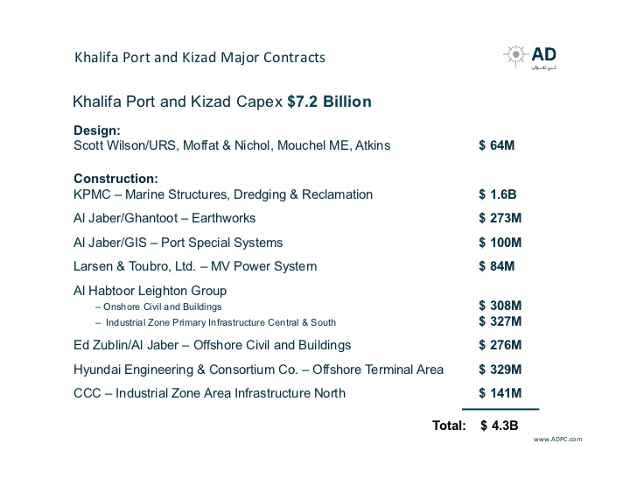
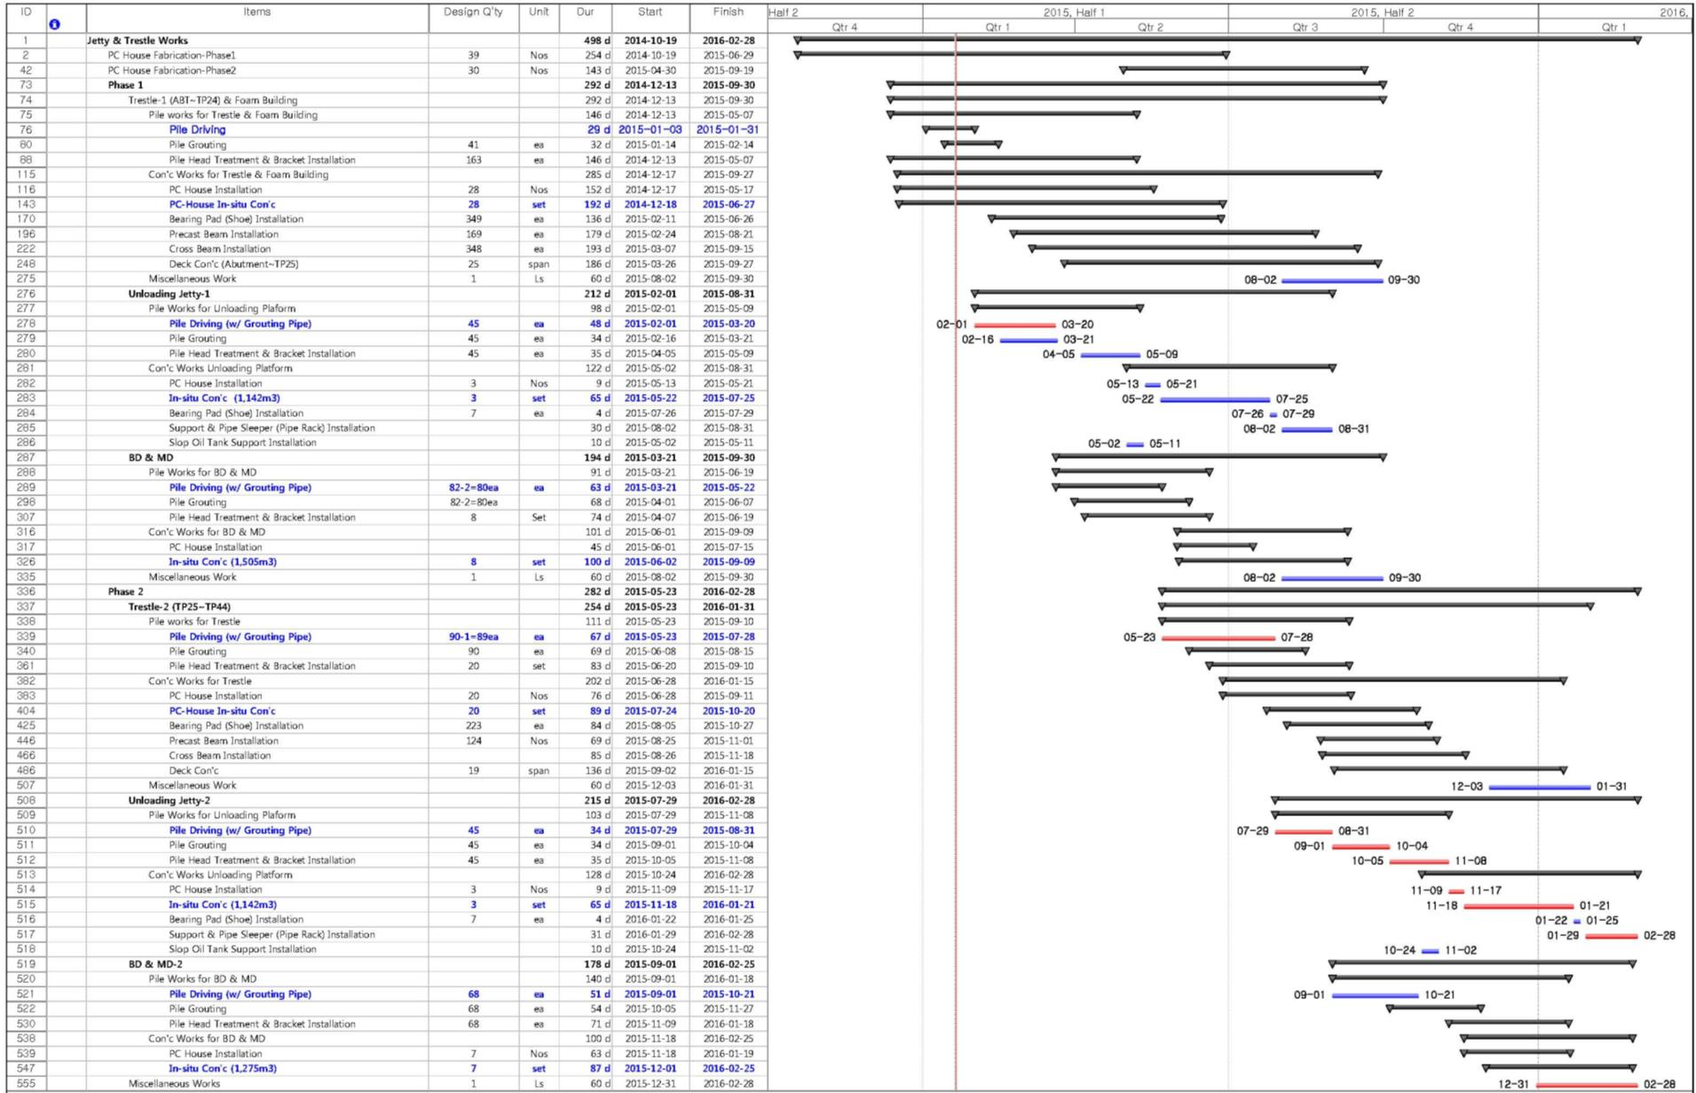
Figure 17 Gantt chart

Khalifa Port Project construction, Challenges, and risks
 |  |  |  |  |  | EXTREME | MEDIUM
 |  |  |  |  |  | HIGH | LOW
 | A | B | C | D | E | G | H
 | RISK DESCRIPTION | PROBABILITY | IMPACT | SCORE | RISK | IMPACT ON PROJECT | RISK MITIGATION / CONTINGENCY PLAN
1 | Deficiency in funds | 1 | 5 | 5 |  | Client will not be able to maintain payment at initial, intermediate and final stages of the project | Contractor all risks insurance (CAR)...offer client a solid payment plan...Offer client operational rights on completed project (port, tidal plant, etc.). Help client to acquire international creditors, or developers to cover project's cost.
2 | Environmental Impact | 3 | 5 | 15 |  | Project will affect marine life in the vicinity of the project.... ecological systems will be harmed with dredging residues material, cutting fluids, oil pollution and spill risks | Apply environmental mitigation plan, including environmental causeway, silt curtains, oil pollution prevention measures, etc.
3 | Social Impact | 3 | 2 | 6 |  | Fishermen will lose part of fishing areas, income of fishermen and fishing ships near shore will be reduced. potential insurance claims, and social unrest | Add artificial aquarium to project's scope. provide loans for fishermen to increase size of fishing ships, training fishermen for alternative activities, jobs in offshore industry.
4 | soil risk. hard soil faced in dredging | 2 | 2 | 4 |  | reduced productivity, delay in delivery | No measures, other than planned .. selected equipment are of proper size.
5 | Weather risks | 2 | 4 | 8 |  | reduced productivity, delay in delivery | more accurate met oceanic studies to be carried out through third party
6 | International pandemic and lockdowns | 1 | 5 | 5 |  | reduced productivity, delay in delivery | Increase local employment in construction phases.... Increase spare parts and material supply from local market. Increase stock onboard vessels.
Table 2 RISK Analysis, Khalifa port Expansion:

Project time schedule and deadlines, internal and external factors affecting delivery
Tight time frame proposed by the client had been a challenge and added the risk of late delivery, application of liquidated damages and additional costs of dely. Environmental restrictions, weather impact on construction vessels, as well as legalization, and permission award processes had imposed additional risk of delay. Cost of delay were not limited to delay charges, and liquidation damages. Construction vessel utilization and the potential of extended standby and idle periods had also been a challenge.
As the project had been of great interest to the client and government of Abu Dhabi, administration and permission risks ad been greatly reduced due to support of the client.
Other challenges arose while working at remote locations up to 18 km from the shore, unprotected from the “shamals” (northwesterly winds) and from swells. The operations of the backhoe dredgers, such as the Wodan, rocky and Colbart which constructed the bunds for the reclamation area for the artificial island 4 km offshore, were influenced by this rough weather during the winter season at the beginning of 2008.
Contractors had managed construction vessels that are less sensitive to sea condition and able to operate in harsh weather.

Environmental Risks
Khalifa Port acquired rewards for safeguarding a national wealth (coral reef) positioned beside Khalifa Port. The coral reef has a size of 35 KM 2 and is the largest coral reef in the United Arab Emirates acting as habitat for thriving marine animals like turtles. The challenge facing Khalifa port is protecting the coral reef and ensuring it benefits from it.
Hydrodynamic modeling established that:
- Construction impacts could be substantially reduced by locating the port island further offshore
- Providinga1km‐longbridgein port access causeway increased long‐shore current flow.
- To mitigate environmental risks and protect nearby coral reef, project had considered construction of 8 kilometers length breakwater around the Port Island protect coral reef at a cost of AED 900 million.

Budgetary Risks
The design of Khalifa port as an offshore island and the huge amount of excavation and land reclamation in a tight strip of the project projected the risk of exceeding budget of construction phases.
Being bounded by environmental sensitive coral reef and the seawater and cooling water intakes for the massive power plants of Taweelah and emirates aluminum ‘EMAL’ on both sides, there had been challenges to contain the effect of dredging and construction operations within the project premises.
Contractor had to consider and apply costly and tight mitigation measures, material had to be stacked to +22 meters height, applying additional environmental and safety risks, as well as the risk of increased material handling costs.

Risk of material and Fuel price costs
The contractor had managed a robust chain supply to ensure flawless supply of material and fuel during the period of project construction.

More specific operational risks related to:
- Determine the type and composition of the soil.
- Weather conditions including events like storms, tsunamis, and earthquakes.
- Wear and tear affecting equipment.
- Technical incidents and breakdowns that might affect the performance, productivity, and availability of the vessels, as well as the efficiency related to cost of operation compared to estimates. e.g., fuel consumption rates per unit volume of soil excavated.
- Default of subcontractor or suppliers, especially in the context of EPCI type contracts.
- Project design and engineering.
- Changes of regulatory frameworks during the contract.
Khalifa port construction phases would boost economic development plans in Abu Dhabi.
To connect the port to local and regional distribution and consumption centers, a great long grid of roads and railways is planned to be constructed.
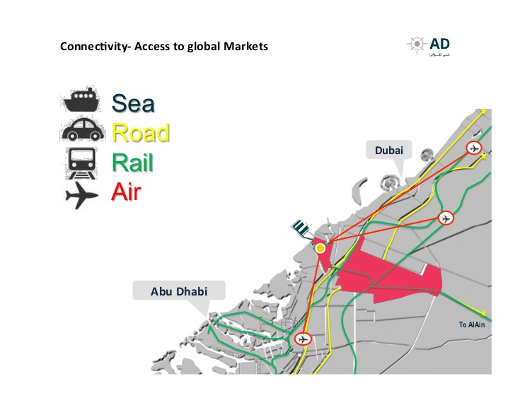
Figure 18 Khalifa port links
Fig.17 Khalifa port links

Bibliography
DEME SUSTAINABILITY REPORT 2019, 2020. SUSTAINABILITY REPORT 2019. [Online]
Available at: https://www.deme-group.com/sites/default/files/2020-05/Sustainability_report_DEME_2019.pdf
Dr. Anjan Datta, 2014. Key Principles for Ports and Harbour Development. [Online]
Available at: https://www.iadc-dredging.com/wp-content/uploads/2016/09/dredging-literature-unep-key-principles.pdf
IADC, 2015. iadc-dredging. [Online]
Available at: https://www.iadc-dredging.com/wp-content/uploads/2017/02/article-challenge-in-logistics-new-suez-canal-project-143-1.pdf
Smit, F., Mocke, G. P., Giarrusso, C. C. & Baranasuriya, P., 2008. COASTAL MODELLING OF THE DUBAI COASTLINE WITH EMPHASIS ON MORPHOLOGICAL MODEL VALIDATION, s.l.: researchgate.
https://micanaldepanama.com, 2015. https://micanaldepanama.com. [Online]
Available at: https://micanaldepanama.com
IADC, 2013. https://www.iadc-dredging.com/wp-content/uploads/2016/07/facts-about-early-contractor-involvement-revisited.pdf. [Online]
Available at: https://www.iadc-dredging.com/wp-content/uploads/2016/07/facts-about-early-contractor-involvement-revisited.pdf
Tadini, M., 2019. A Geographical Overview of the Suez Canal Freight Flows: an Impact on the Mediterranean Sea and the Genoa port. Bollettino della Società Geografica Italiana , Issue 14.
BACCELLI, O., BUONFANTI, A. A., FERRARA, O. & ZUCCHETTI, R., 2019. The new Suez Canal: economic impact on Mediter- ranean maritime trade.. www.srm-maritimeconomy.com.
VAN BEMMELEN, B. et al., 2016. CHALLENGE IN LOGISTICS: NEW SUEZ CANAL PROJECT. Terra et Aqua.
Nyrkov, A., Sokolov, S., Chernyi, S. & Mamunts, D., 2015. Using Information Technologies In Dredging. Metallurgical and Mining Industry, Volume 6.

